**EEG DATA ANALISYS THROUGH EEGLAB**

**To Download EEGLAB**

Download eeglab <https://sccn.ucsd.edu/eeglab/download.php>

Unzip folder inside your MATLAB/toolbox folder.

Open Matlab and on command window write:

*addpath('/YOURPATHTOMATLAB/toolbox/eeglab2020_0')*

Then write:

*eeglab*

to open the GUI.

**A bit of theory**

**Epoching**: EEG epoching is a procedure in which specific time-windows are extracted from the continuous EEG signal.

These time windows are called “epochs”, and usually are time-locked with respect an event e.g. a visual stimulus.

If your EEG data are in a matrix [channel x time] where time is the complete continuous EEG signal, after the epoching procedure you should have a matrix [channel x time x epochs] where time is the time length of each epoch, and epochs is the number of segments you extracted from continuous EEG signal.

If you want to extract epochs from your signal, you should know what are the segments of interest to be analyzed, for instance, a specific stimulus.

Electroencephalogram (EEG) data are typically contaminated with artifacts (e.g., by eye movements).

The effect of artifacts can be attenuated for example with the Independent component analysis (ICA) that separates EEG data into neural activity and artifact; once identified, artifactual components can be deleted from the data.

**ICA (Independent Component Analysis):**

Signal processing method to separate independent sources linearly mixed in several sensors. We use it because different source points of EEG signals produce signals that are then captured by different electrodes and we need to separate the information obtained.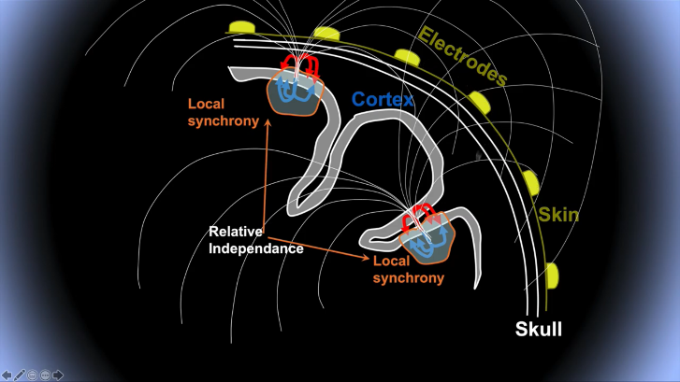

It recovers the original sources by multiplying the data X by an unmixing matrix W:

U=WX

X: data (channels x time)

U: ICA source activities (component x time)

W: ICA unmixing matrix (components x channels)

Example of ICA applied to EEG:

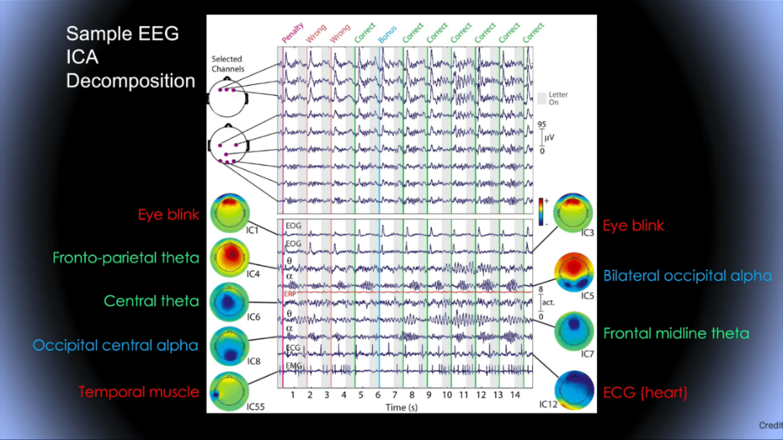

**To analyze data (**Notice: parts in italic are the buttons to click)

IMPORT INTO EEGLAB

*file -> load existing data* : load your dataset

*plot -> channel data (scroll)* : see your dataset

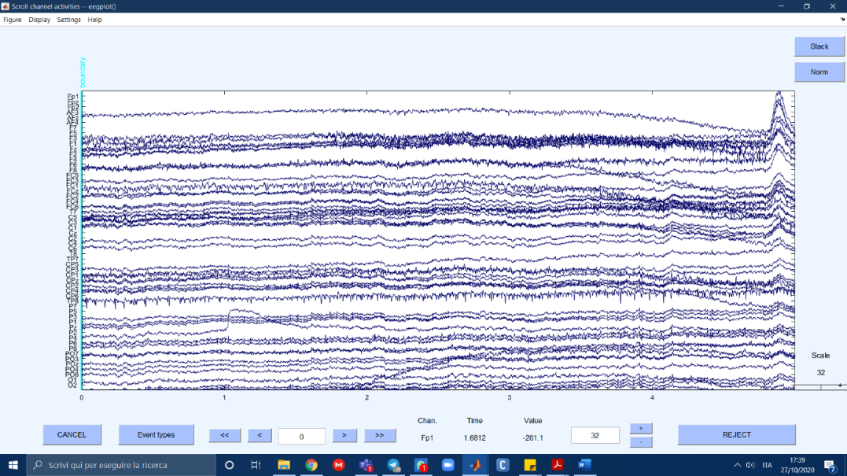

IMPORT CHANNEL LOCATIONS

*Edit -> import channel locations mni coord -> ok*

->Plot 2d

->Plot 3d

DOWN-SAMPLE

*Tools -> change sampling rate* -> write your rate (here 250)

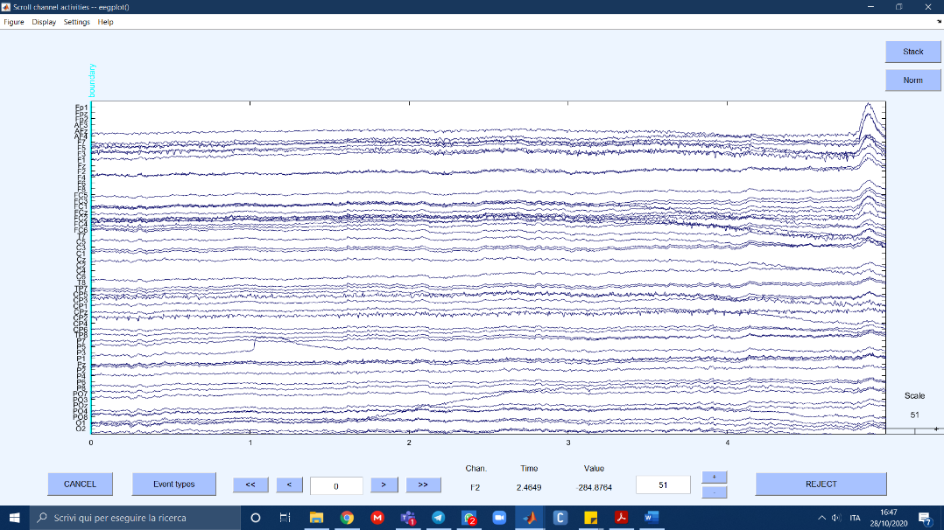

FILTER THE DATA

*Tools -> filter the data -> basic FIR filter* -> set high and low values (here: 1-80)

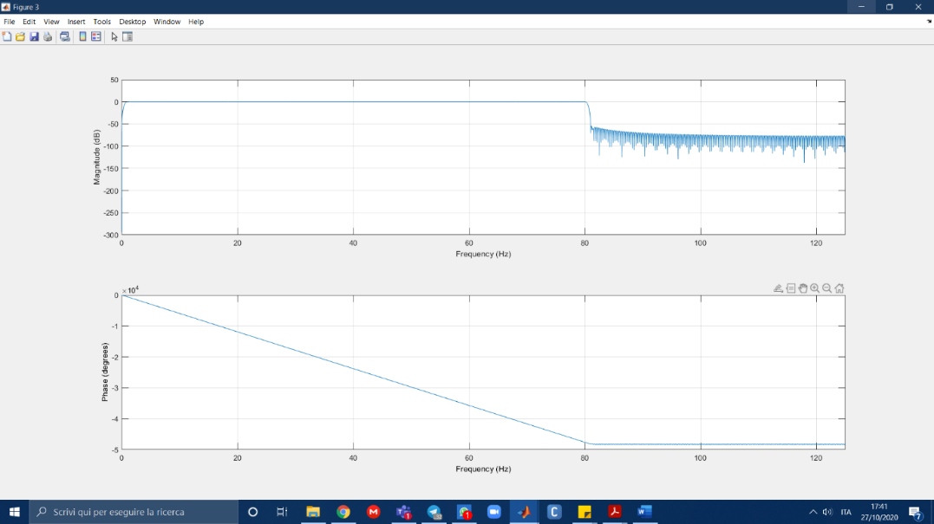

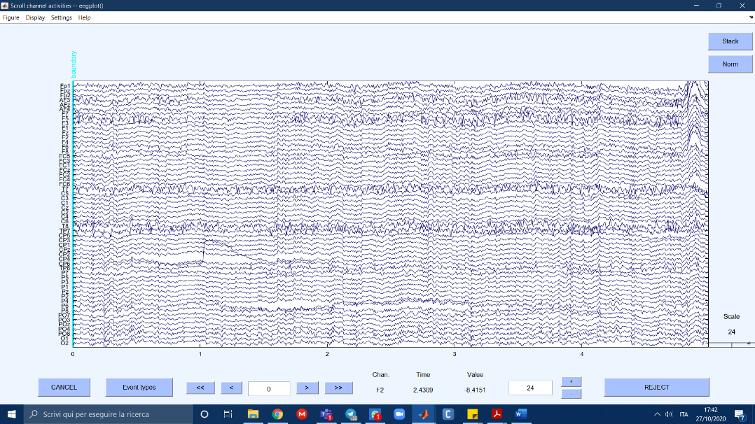

*Tools -> filter the data -> notch filter* -> set values around your desired value (here: 45-55)

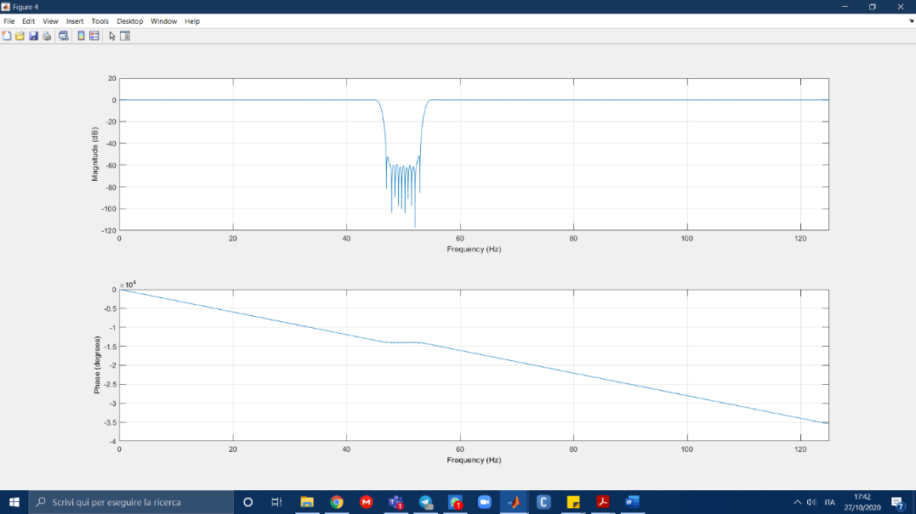

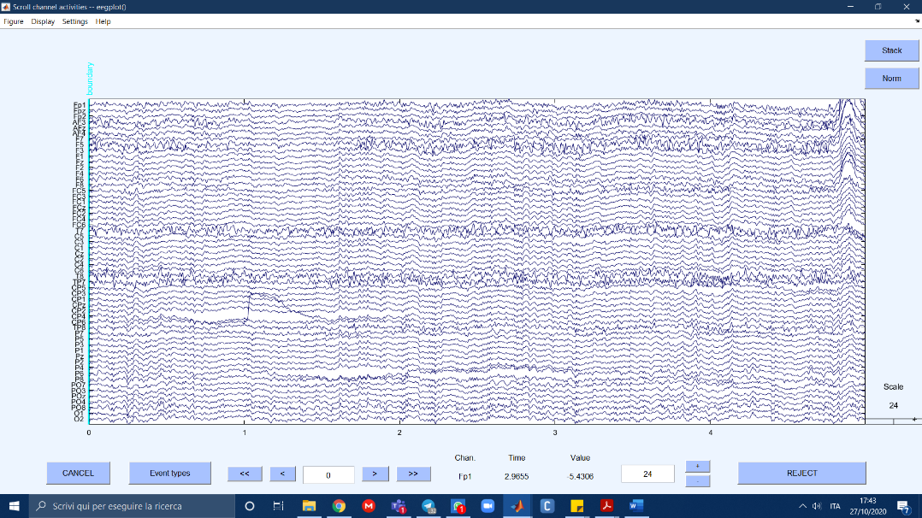

EXTRACT EPOCHS

*Tools -> extract epochs*

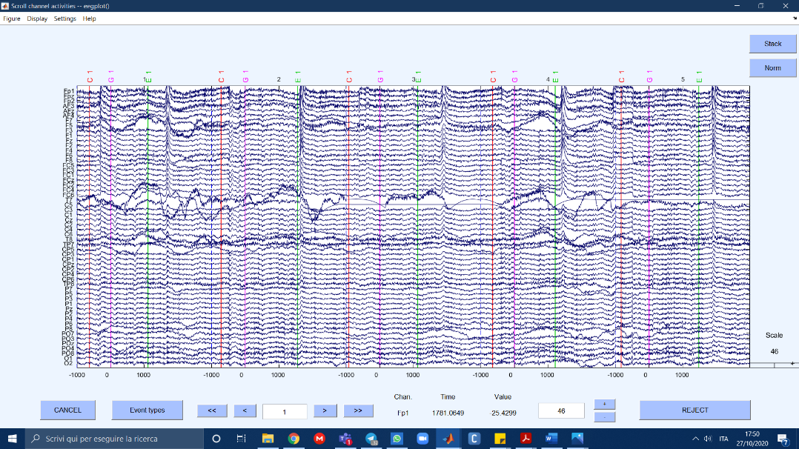

Data set brief description: The events are of three types:

1. C: see red target.
2. G: target becomes pink: go towards it with your arm+ee.
3. E: movement finishes.

We try this multiple times then make an average of the data. Synchronization is important since we can link EEG data to real events. Data is like a matrix channels x epochs. You can remove either an entire row or an entire column, not pieces or u can’t do the analysis.

EXAMINING RAW DATA (already done)

*Tools -> Reject continuous data by eye*

*plot -> channel data (scroll)*

TIME LOCKING EVENT TIPE

*Tools -> extract epochs -> time-locking event type* -> write the desired type (here: G).

*Epoch limits ->* write limits (here -1,3)

REMOVING BAD CHANNNELS (check chapterExamples of bad channels/epochs):

*Plot -> channel data (scroll) ->* choose “bad channels”. Here: see images

*Plot -> channel spectra and map ->* if there’s any line which completely doesn’t match the rest: bad channel

*Edit -> select data ->* select the unwanted channels and check box!

Here: T7, C5 create big problems in the first data, we removed them.

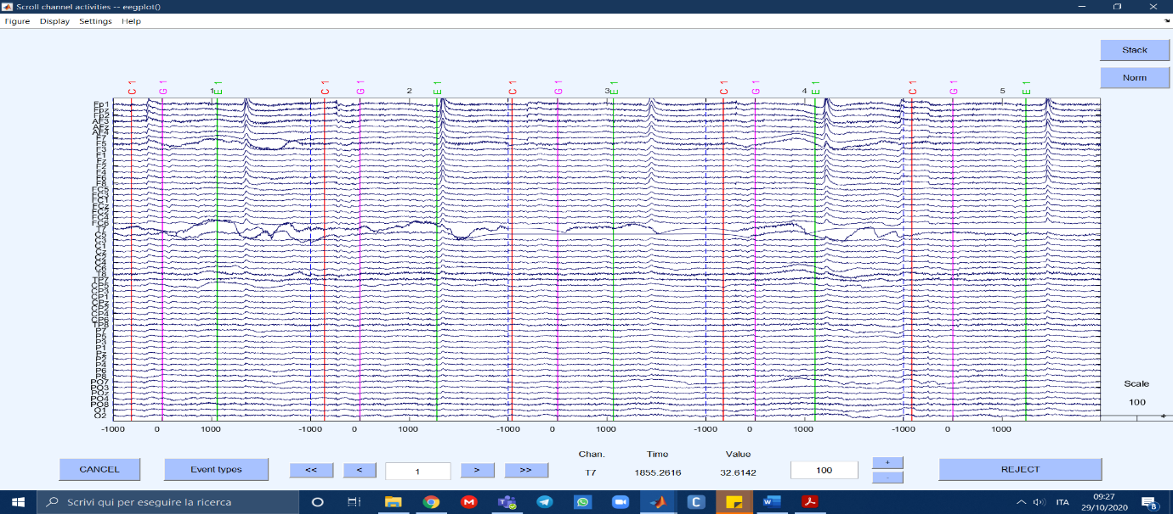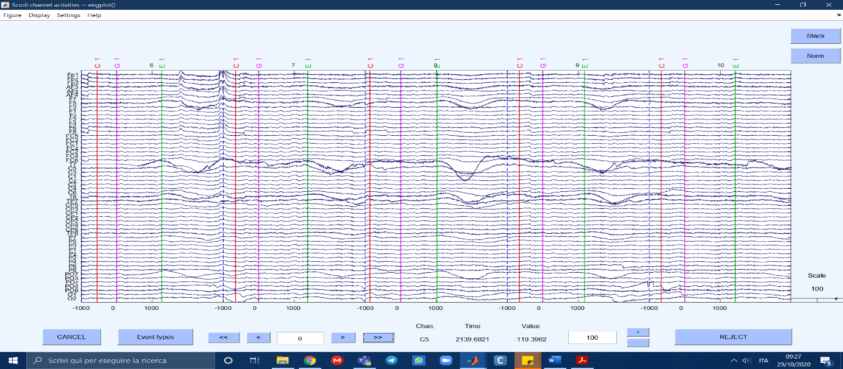

From spectra plotting, instead, we didn’t notice many anomalies:

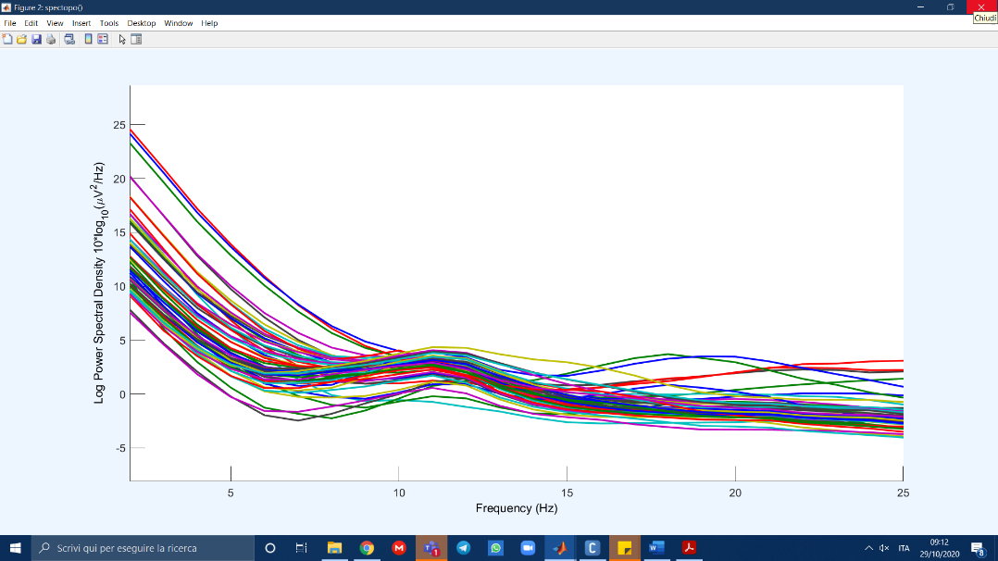

REMOVING BAD EPOCHS

Don’t remove eye blinks: they will be removed by ICA. Remove high frequency epochs that don’t make sense. Remove electrode artifacts.

*Plot -> Channel data scroll -> Settings -> Time range to display ->* set a higher time range to have a better view *-> stack -> norm* -> the channels that don’t match with the others are outliers

Here: we removed 37 epochs: the ones with removed elecrodes, the ones with high frequency muscular data,…

RUN ICA

*Edit -> Channel locations -> Use MNI coordinates for the BEM Dipfit model*

*Tools -> ICA decompose data by ICA* (it takes a while)

Plot -> Component maps -> 2D

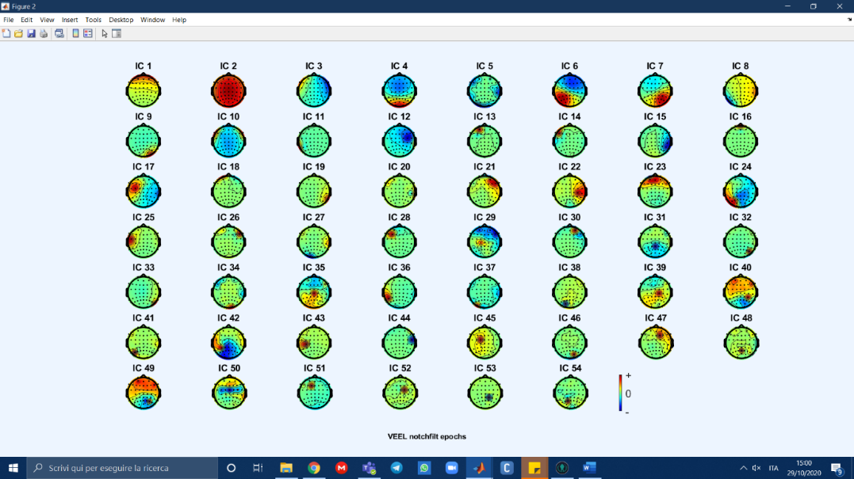

REJECT DATA USING ICA:

*Tools -> Inspect/label components by map*

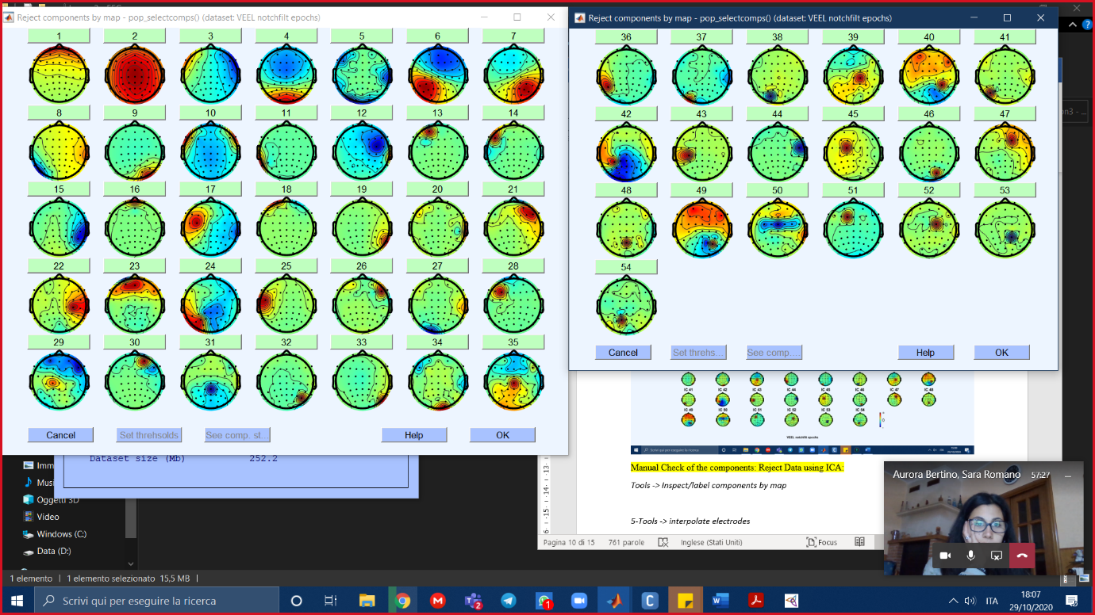

Click on each and choose to keep it or not. Ex:

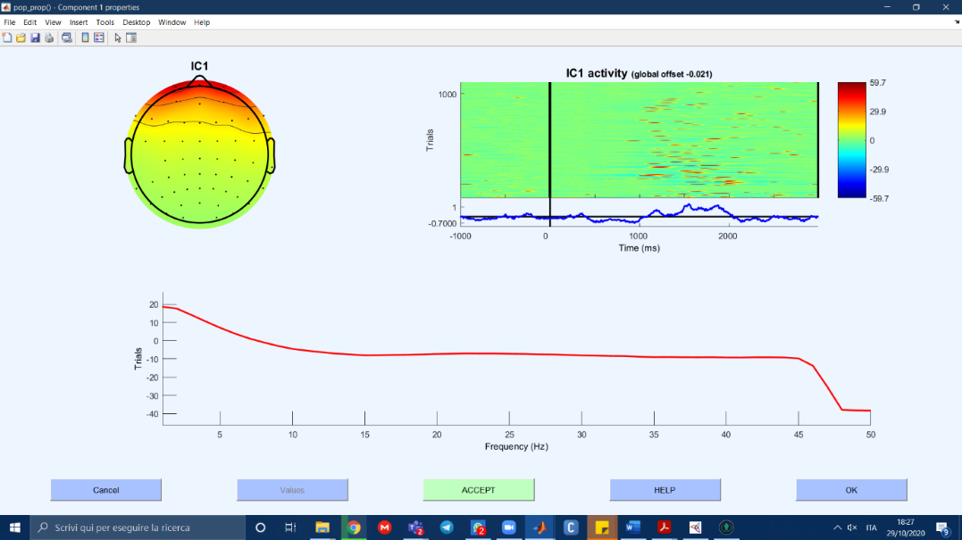

HOW TO DECIDE WHETHER TO KEEP OR NOT:

Brain:

* Scalp topography often looks dipolar
* Residual variance from dipole fit (marked RV on images) should be low. Usually below 15% unless the component is better explained with two dipoles
* Power spectrum decreases as frequency increased (1/f)
* Power spectrum usually has peaks between 5 and 30 Hz, most often at 10 Hz
* Epoched data will likely have a visible ERP

Eyes:

* Scalp topographies suggest ECDs near eyes
* Power concentrated at low frequencies (below 5 Hz)
* Vertical eye movement components will contain blinks in the data
* Horizontal eye movement components will look like step functions

Muscle:

* Power concentrated in higher frequencies (20 Hz and above)
* Can still be dipolar, but will be located outside the skull

Heart:

* Clear QRS complex in the data at about 1 Hz
* Near linear gradient scalp topography
* No peaks in power spectrum

Line noise:

* Strong peak in power spectrum at either 50Hz or 60Hz

Channel noise:

* Very focal scalp topography
* Large and/or consistent artifacts in the component activations.
* Easily confused with muscle components, but PSD is different.

Other:

* Anything that doesn't fit the above categories.
* More likely the higher the IC number (as in IC 150 of 220 is *very* likely to be "Other"
* Non-dipolar scalp maps
* Spectrum can still have weak 10 Hz peak as brain signals are likely mixed with other signals

When you are finished deciding:

*Tools -> Remove components from data* (the ones you rejected are already there).

*-> Plot single trials*: how channels change after rejection.

*-> Plot ERP*: check if it looks good.

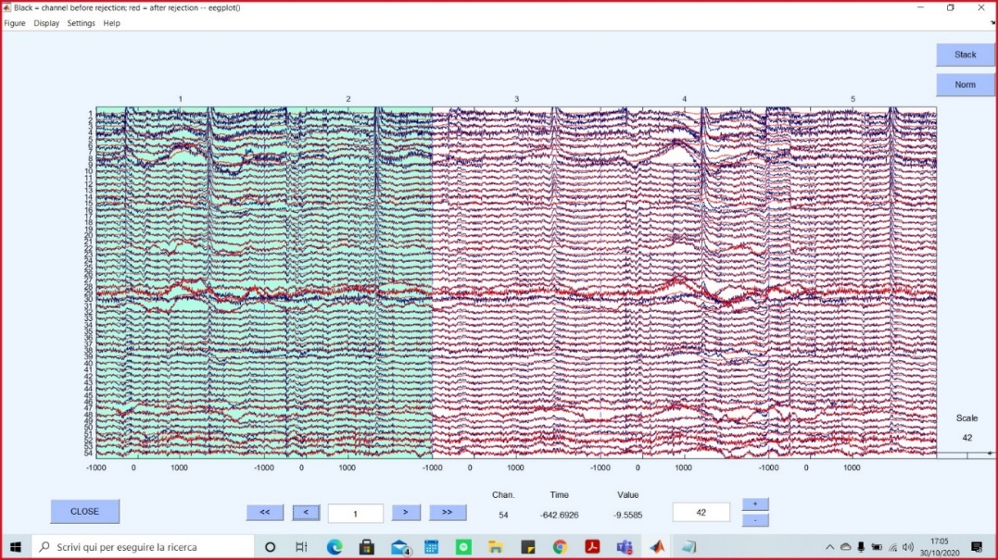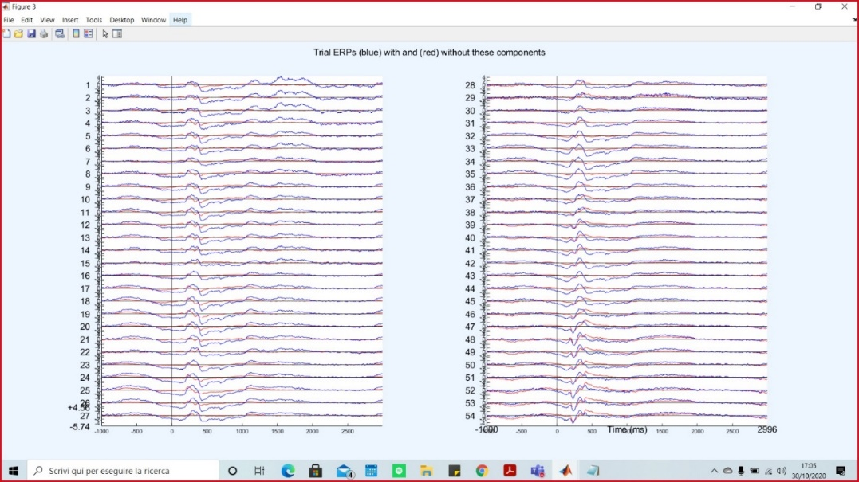

INTERPOLATE CHANNELS

*File -> Load existing dataset -> Preprocessed_dataset*

*Datasets ->* select Dataset(1) (the current)

*Tools -> interpolate electrodes -> use specific channels from other dataset ->* write the index of the preprocessed dataset-> choose the channels you previously removed

REFERENCE AVERAGE

*Tools -> re-reference the data*

DIVIDE BY FREQUENCY

*Plot -> channel spectra and map -> Plotting frequency range:* write the desired frequency.

*Percent data to sample:* write 100

Frequencies:

(Gamma 30 – 100 Hz –> higher cognitive functions, i.e. memory/learning)

Beta 14/15 – 25/30 Hz -> movements

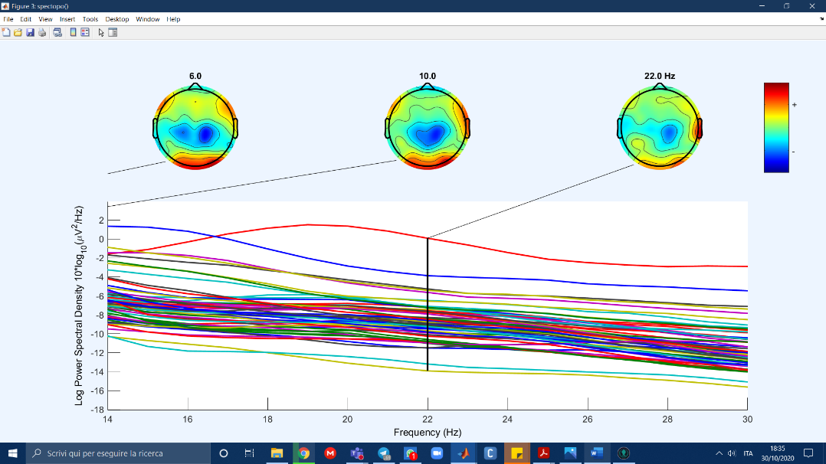

Alpha 7/8 – 13 Hz -> eyes closed

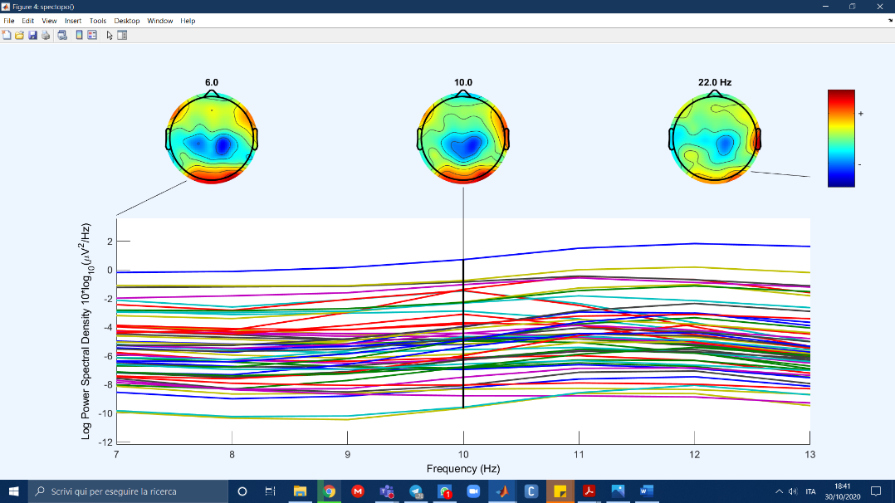

Theta 4– 7/8 Hz -> attention

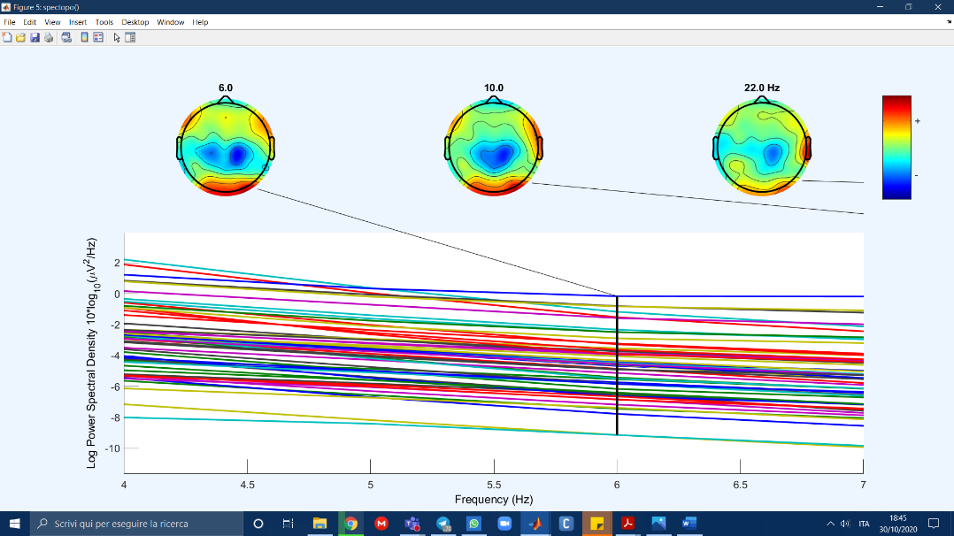

Delta: 0.5 – 4 Hz -> sleep

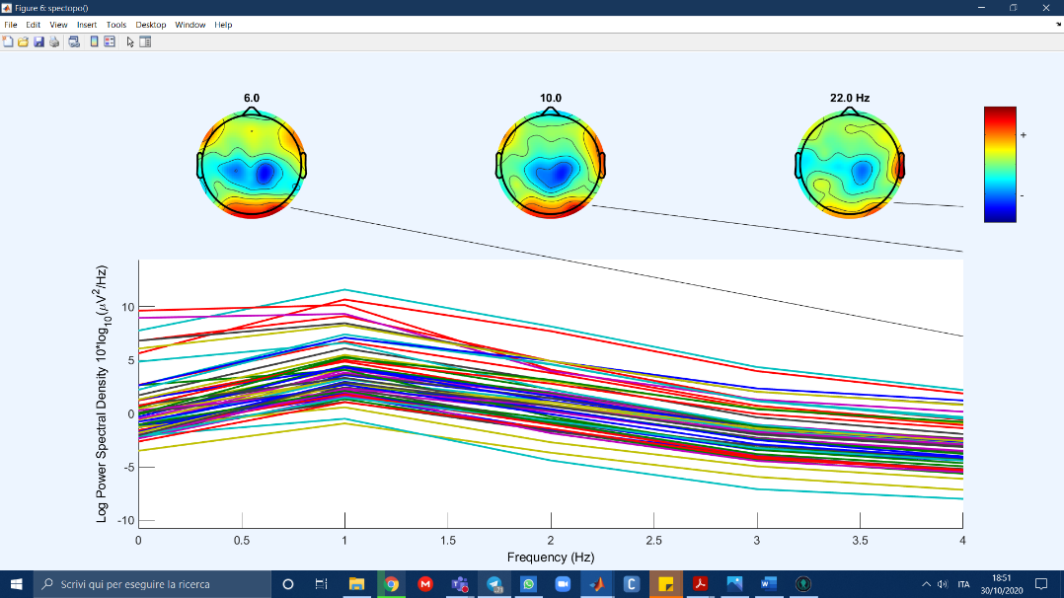

Together:

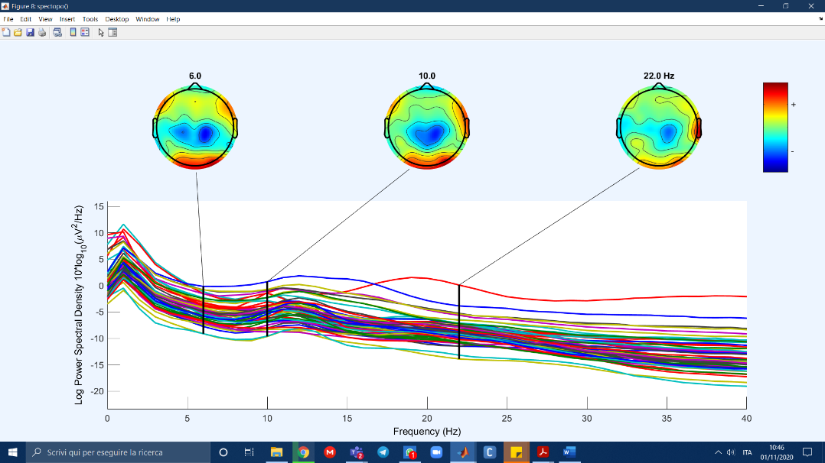

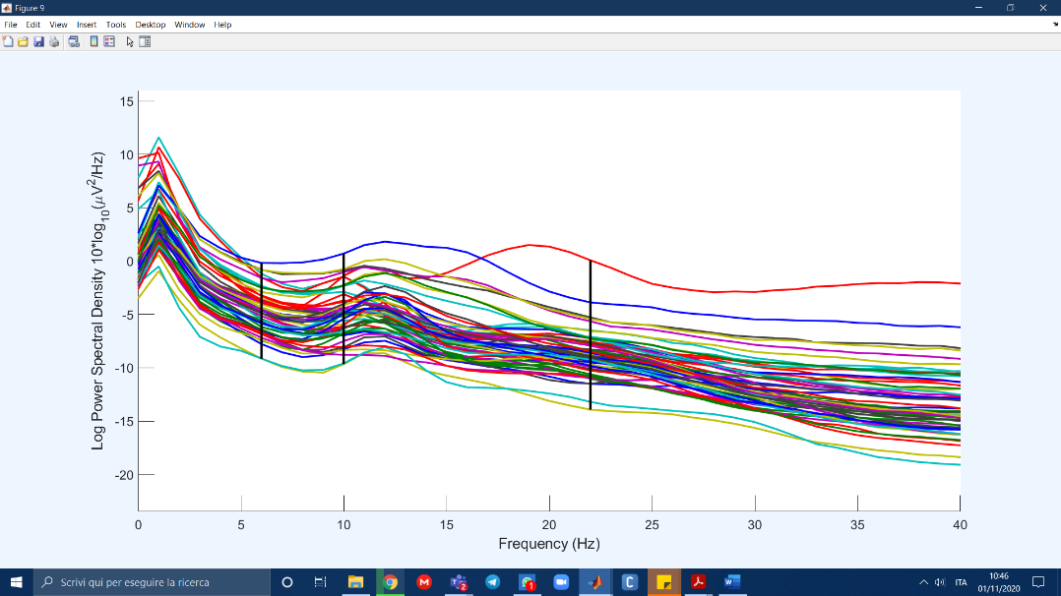

The peaks are around 11-16Hz and 19-21Hz, which are respectively in the eyes closed and movement frequency ranges. The areas in which they are concentrated are the occipital area.